**Using Agisoft Metashape to generate Structure from Motion (SfM) derivatives from DJI RGB, MAPIR RGN and TIR.**

**Scott Nowicki**

(For Micasense 10-band data see instructions here: https://support.micasense.com/hc/en-us/articles/360002693373-Process-MicaSense-sensor-data-in-Agisoft-Metashape)

This activity requires an active version of [Agisoft](http://www.agisoft.com/downloads/request-trial/) Metashape. You will also need to have access to QGIS (or ArcGIS) or [GoogleEarthPro](https://www.google.com/earth/download/gep/agree.html) for some of the analysis.

A tutorial for completing a basic project using Agisoft can be [downloaded here](http://www.agisoft.com/pdf/PS_1.3%20-Tutorial%20(BL)%20-%20Orthophoto,%20DEM%20(GCPs).pdf). This tutorial will show how to generate a spectral cube from multiple imaging systems, appropriate for multispectral analysis. **You will need to read this entire tutorial.** You have very little chance of making it through this workflow without reading it.

**Part 1. Starting with the DJI RAW imagery:**

1. **Add Photos** or **Add Folder** from the Workfow menu

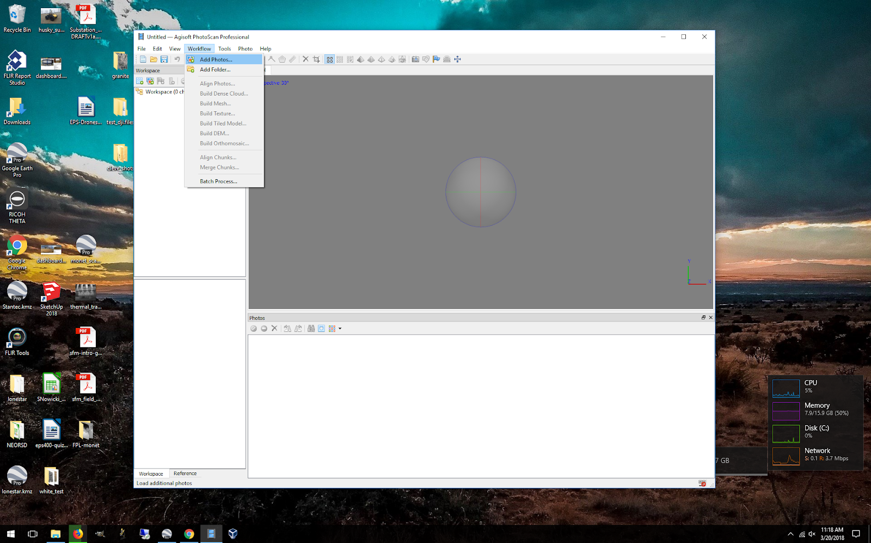

If your images have geotagged positions (stored in the EXIF) then the lat, lon and altitude will automatically be loaded into the Reference dialogue. Images collected by the DJI integrated camera will have EXIF location information. MAPIR imagery and FLIR thermal imagery will need an extra processing step, described below.

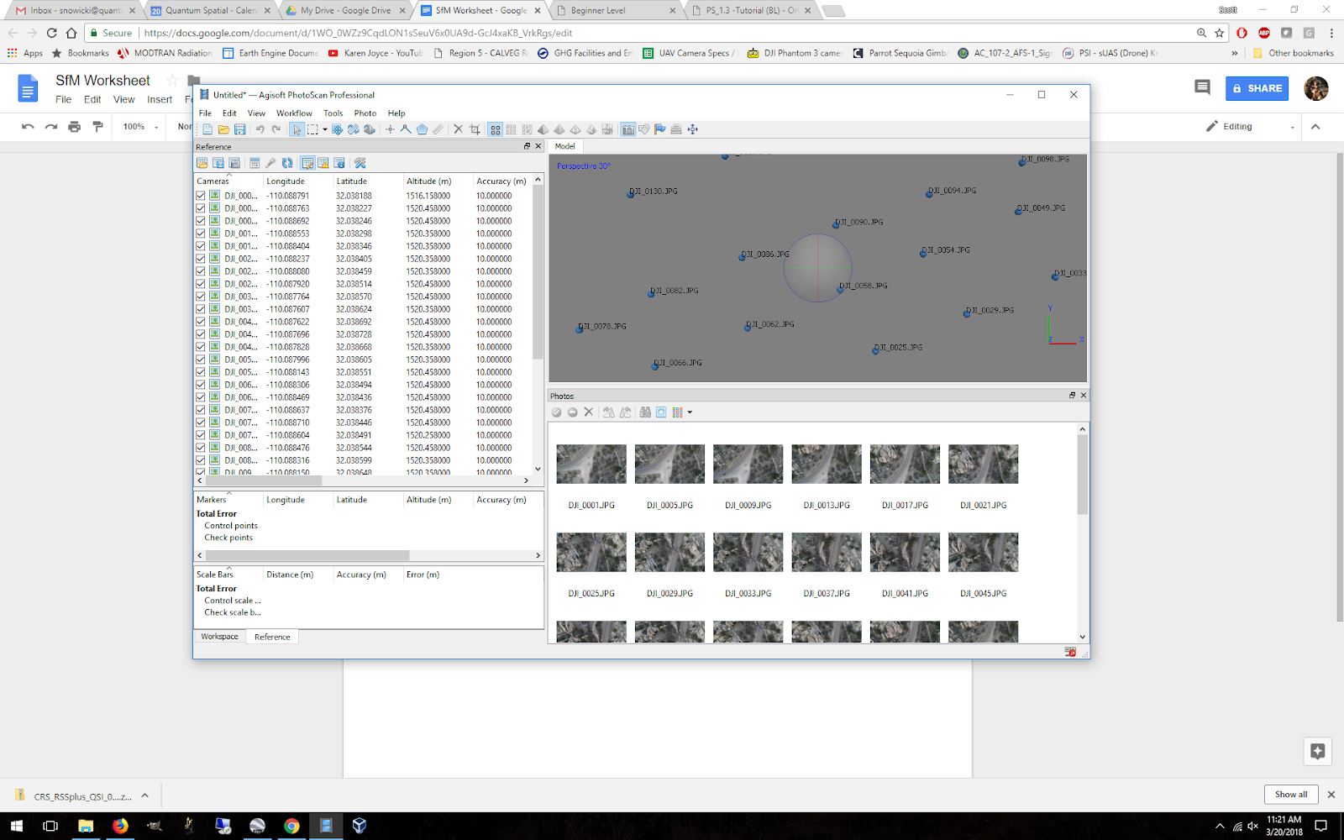

If the images do not have EXIF location data, and you have position data from a different source, **Import** the positions in the reference dialogue as a txt or csv file.

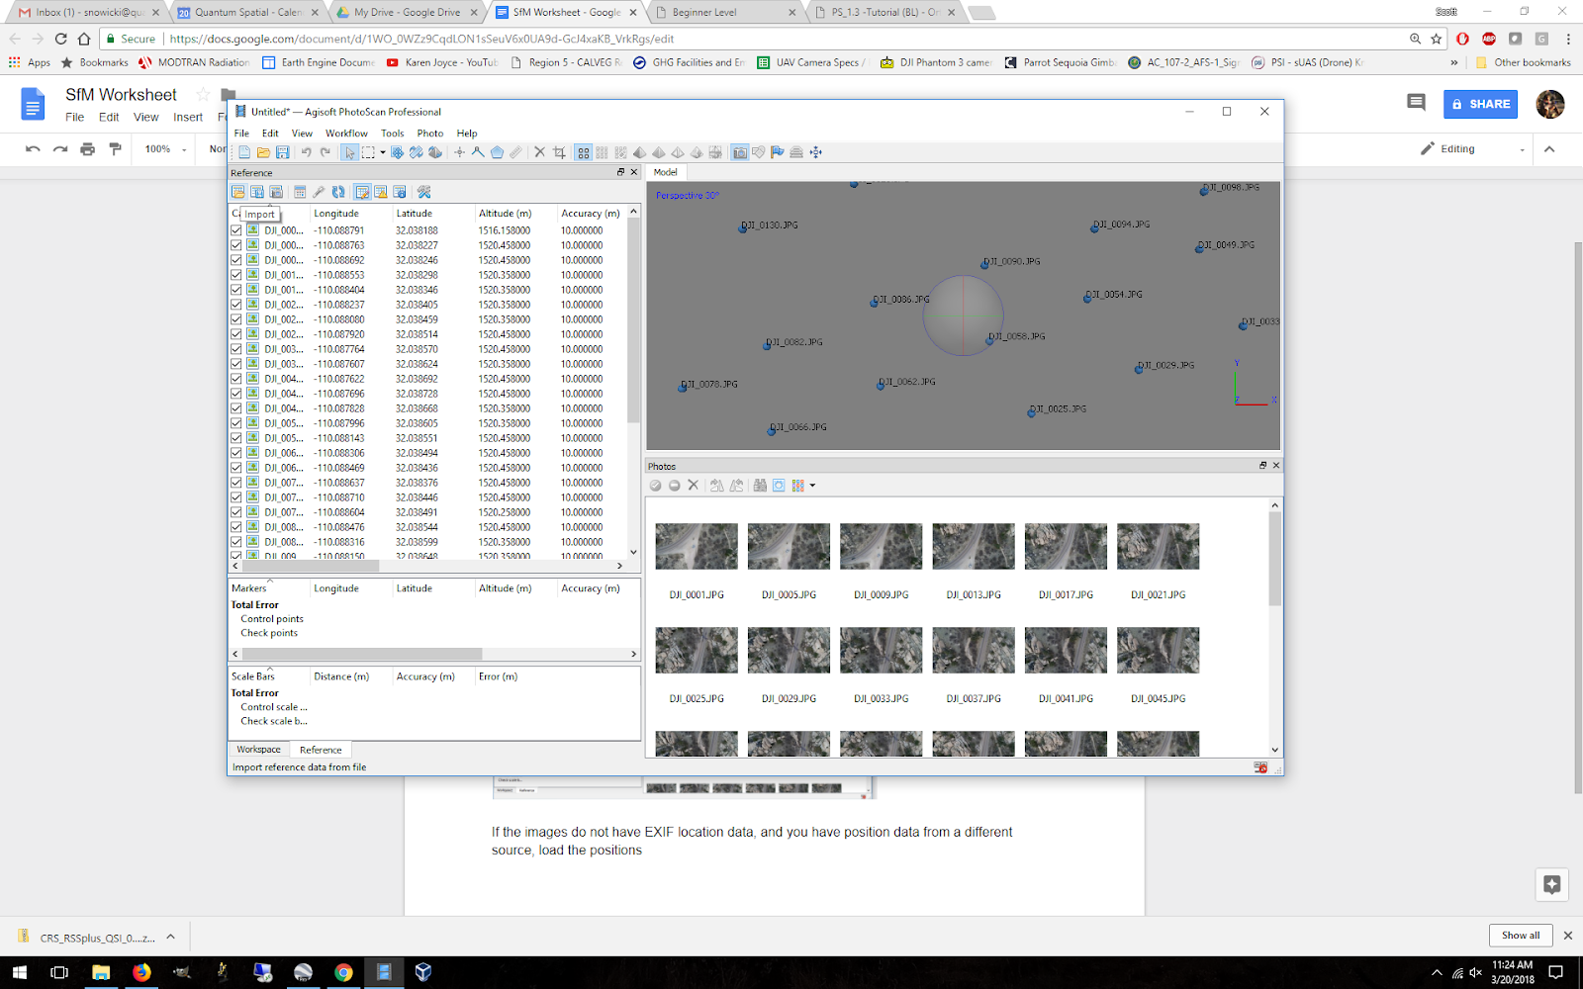

2. **Align Photos** from the Workflow menu. For most field collects, a key point limit of 100,000 and tie point limit of 20,000 are good starting values. For stabilized imagery, you typically do not want to use an adaptive camera model. For unstabilized rolling shutter imagery, adaptive may work better. This step may take a long time depending on the number of pictures and degree of overlap. Reducing the accuracy may speed up this step.

You may want to run the Align Photos tool multiple times with different qualities. Start with a higher quality and decrease to medium or low if there are a number of images that do not align.

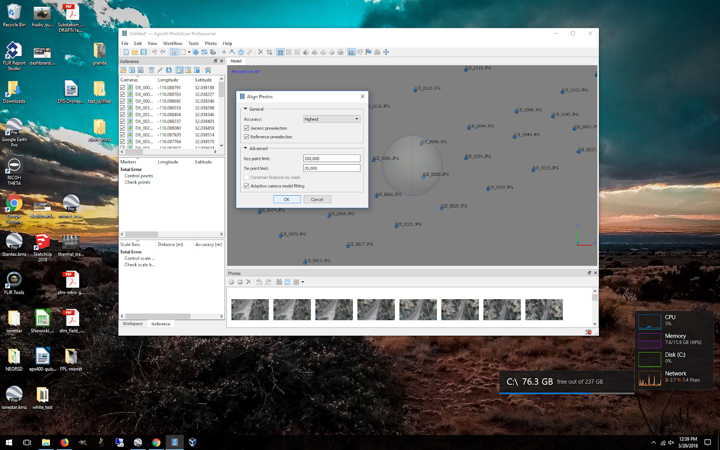

3. **Import GCPs or Place Markers.** If you collected GCPs with a GPS, use a spreadsheet of locations to create markers. If you are using Google Earth to select GCP’s (and therefore not creating a peer reviewable project) the best way to do this is by creating a CSV of GCPs (gcp name, latitude, longitude, altitude) and importing them into the project.

After the photos have been re-aligned, you may need to edit the point cloud by removing points that are obviously erroneous. See the tutorial for more information. You may also want to reduce the bounding box to your area of interest, and cut out portions of the point cloud that are projected outside your AOI. .

4. **Optimize Cameras** from the Tools menu.

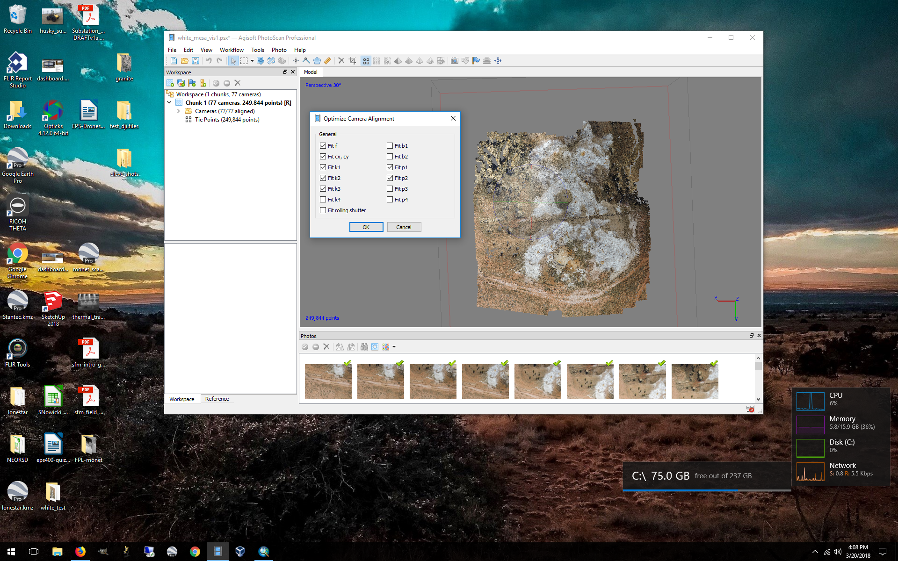

5. **Build Dense Cloud** from the Workflow menu. The quality will affect processing time. For solid surfaces, use depth filtering. For non-solid objects (tree canopies or complex 3d structures), use little to no depth filtering.

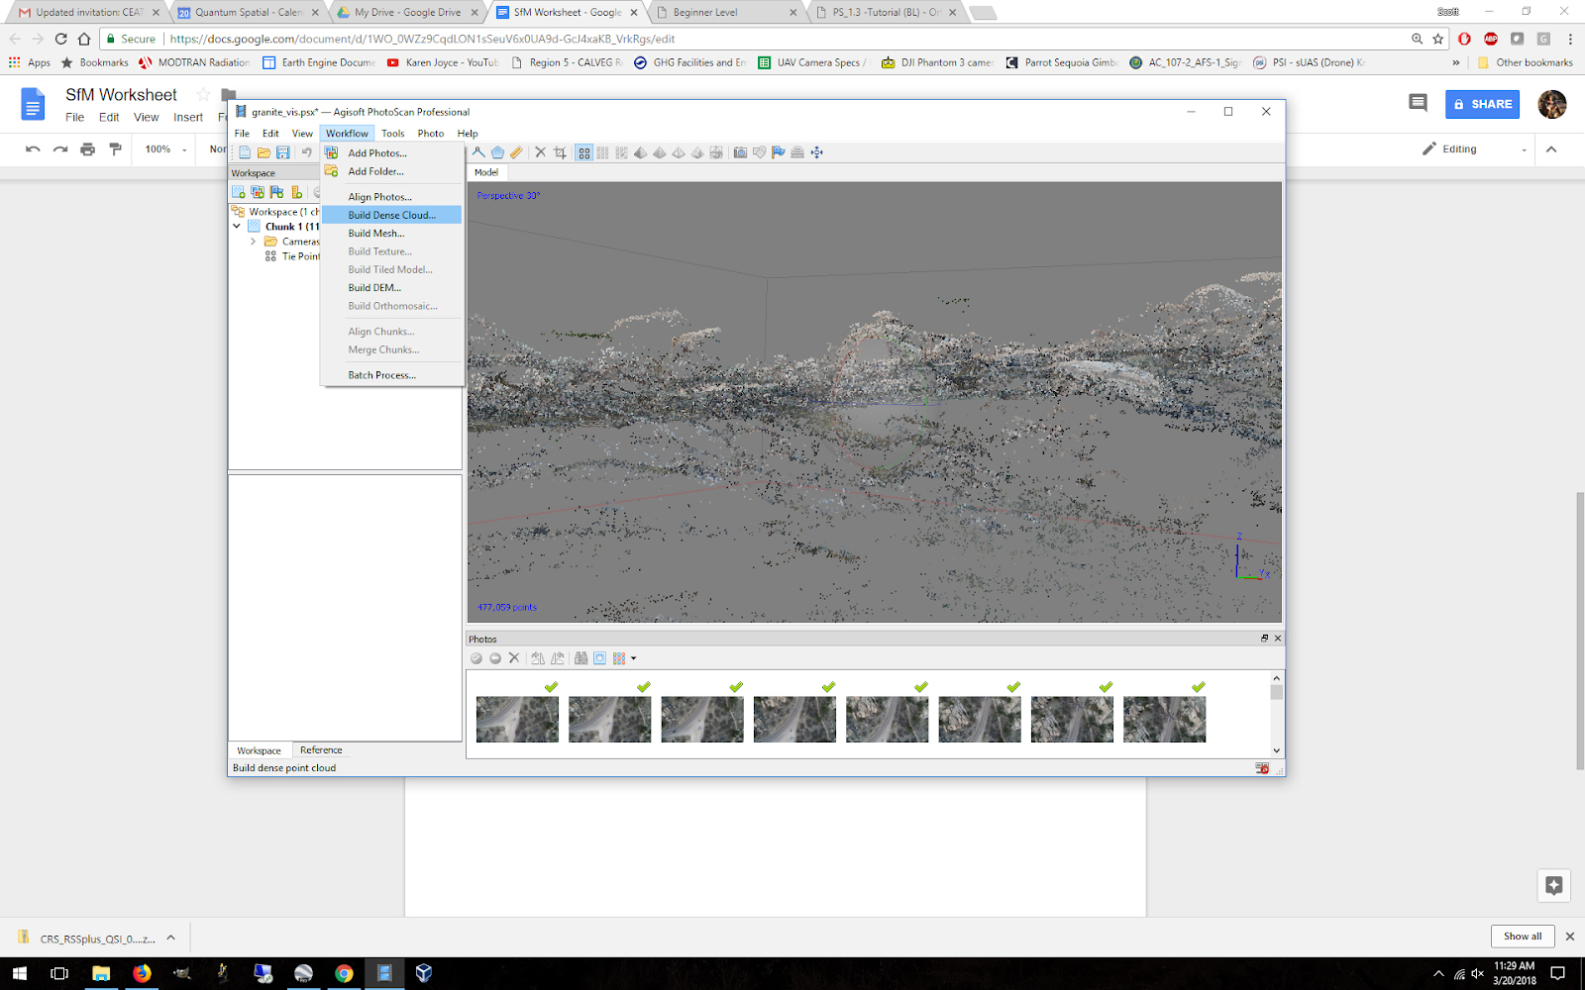

6. **Build a Mesh** from the Workflow menu. For solid surfaces use Height Field, and Dense Cloud.

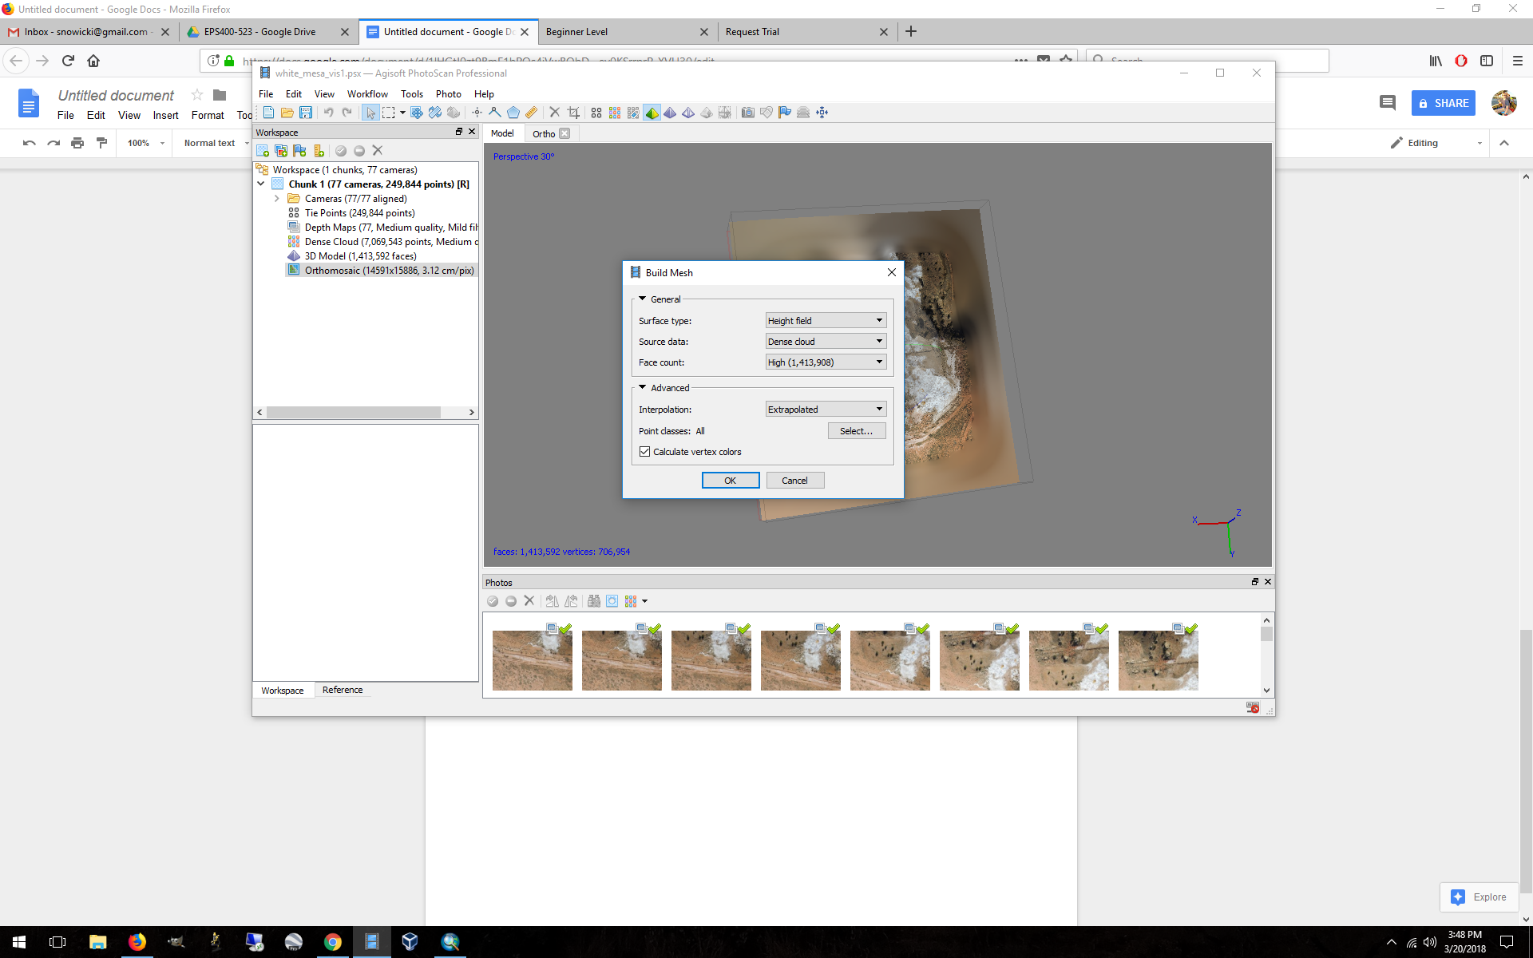

7. **Build a DEM** using the dense cloud. Depending on what you are trying to do, you probably want to leave the DEM in geographic (WGS84) coordinates rather than in a projected coordinate system. Export the DEM in the projection you like. If you plan on making a shaded relief map with this DEM, you need to use a projected coordinate system (UTM, etc), otherwise your GIS won’t know where the sun is (you’ll see what the problem is when you try to do this).

8. **Build Orthomosaic** from the Workflow Menu.

You can choose the projection, resolution, and surface (DEM or Mesh) to project to. Starting with the defaults is a good choice.



9. **Output your orthomosaic** by right-clicking on the Orthomosaic layer in the workspace window, Save mosaic as a geotiff, or you can generate a kmz for googling.

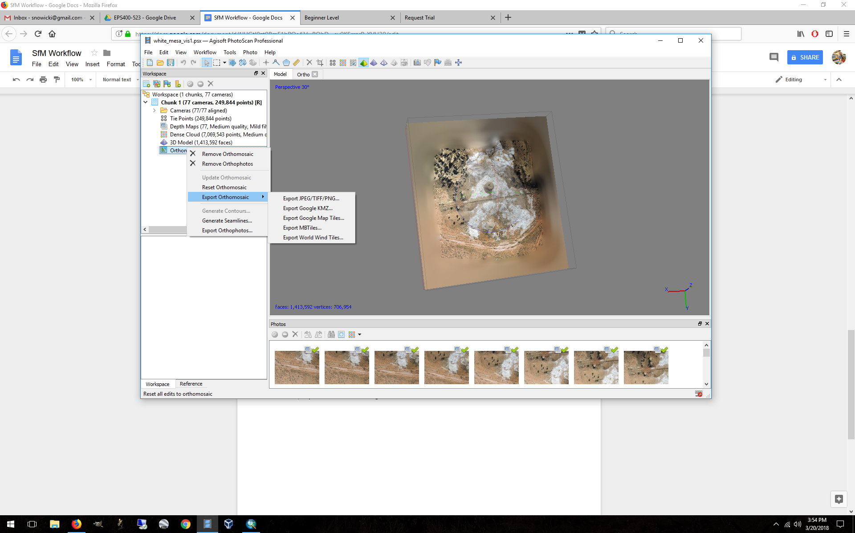

10. To include analysis with a co-acquired multispectral camera, start a new project and follow steps 1-2 with the MAPIR Raw imagery.

11. Select a number of GCPs from the visible project to use in your MAPIR project, and Optimize cameras using the new set of GCPs.

Import the DEM that you generated using the DJI imagery.

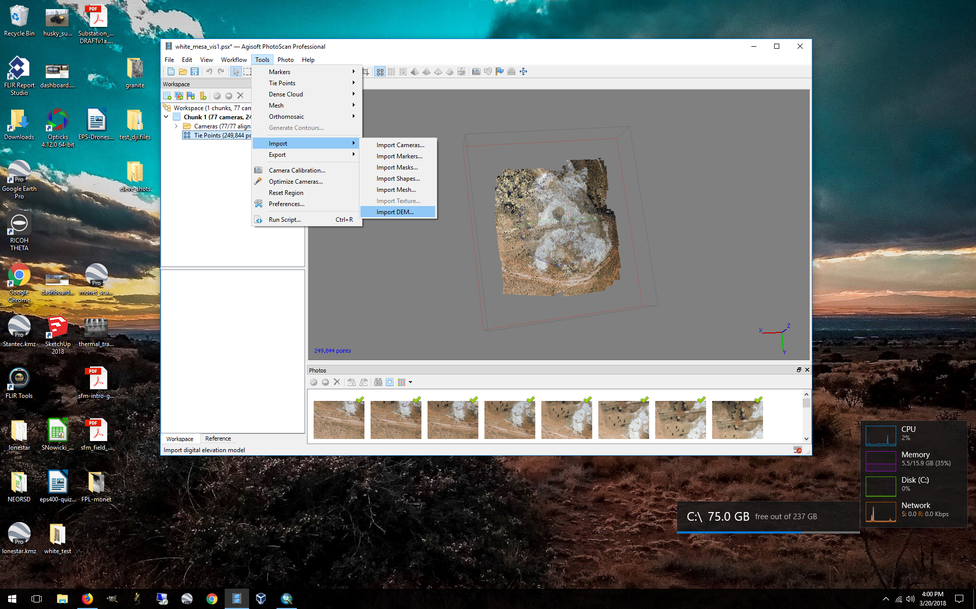

12. Using the camera positions generated from the photo alignment, **Build Orthomosaic** by projecting onto the DEM.

13. Output the mosaic as a geotiff.

14. Open both images in a GIS to check the alignment between the mosaics. Or import the geotiffs to GoogleEarthPro.

**Part 2. Processing the MAPIR camera RAW imagery**

In order to get the MAPIR RAW imagery into a form that Agisoft can import, you will need to convert RAW to tiff. This can be done a number of ways, but MAPIR has written the MAPIR Camera Control (MCC) application to do this.

<https://www.mapir.camera/collections/software/products/mapir-camera-control>

This is capable of importing both the RAW+JPG files to generate geotagged tiff files.

As a reminder, the camera we are using is the MAPIR Survey 3 Wide-angle RGN camera.

If you used the calibration target, you may be able to calibrate all your imagery to reflectance, but this step is not required.

<https://www.mapir.camera/pages/calibrating-images-in-mapir-camera-control-application>

**Part 3. To process thermal infrared imagery collected using the co-mounted Vue Pro**:

1. Place both DJI visible and FLIR imagery in the same folder and display by date.

Delete all imagery that does not alternate between DJI and FLIR by time. Make sure that each successive image is within 1 second.

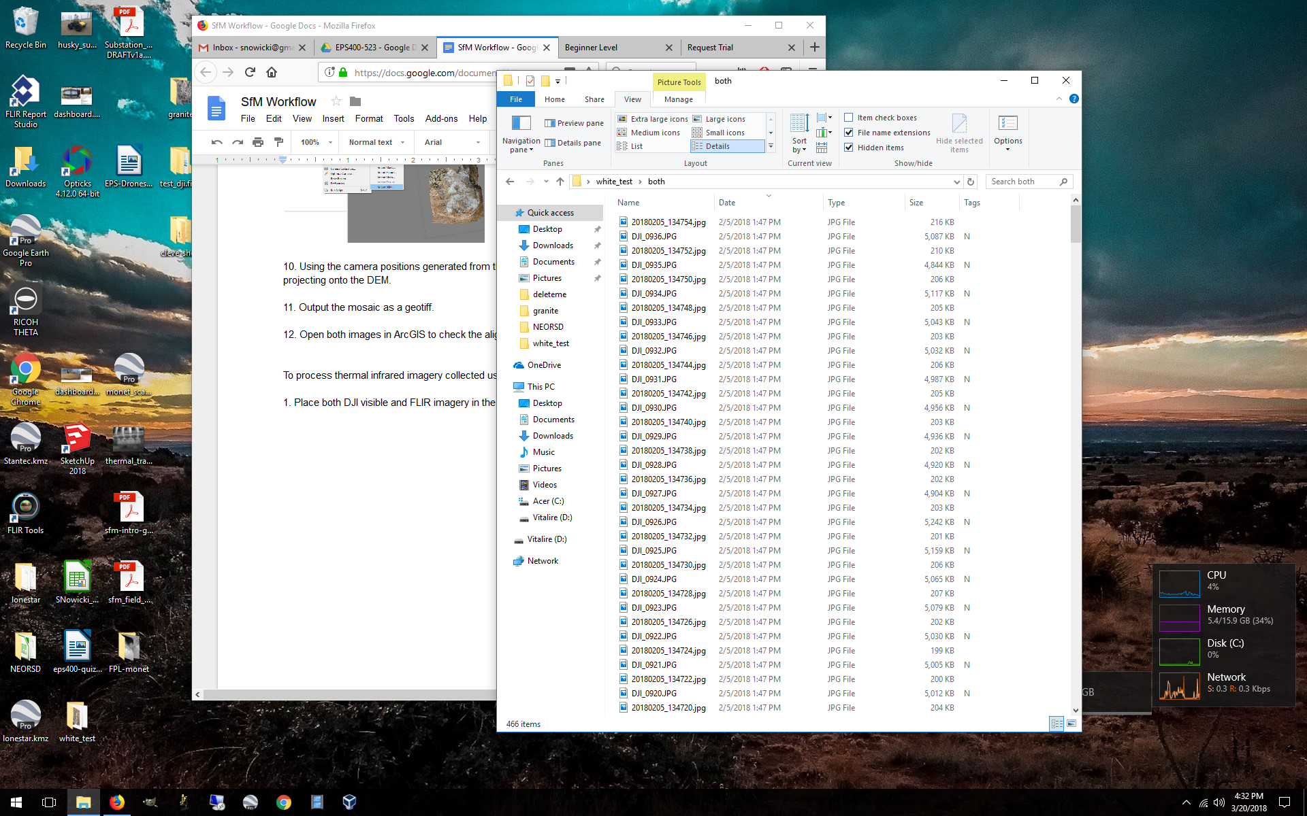

2. Add the DJI photos to a new project.

3. Switch to the Reference dialogue, and Export the reference file.

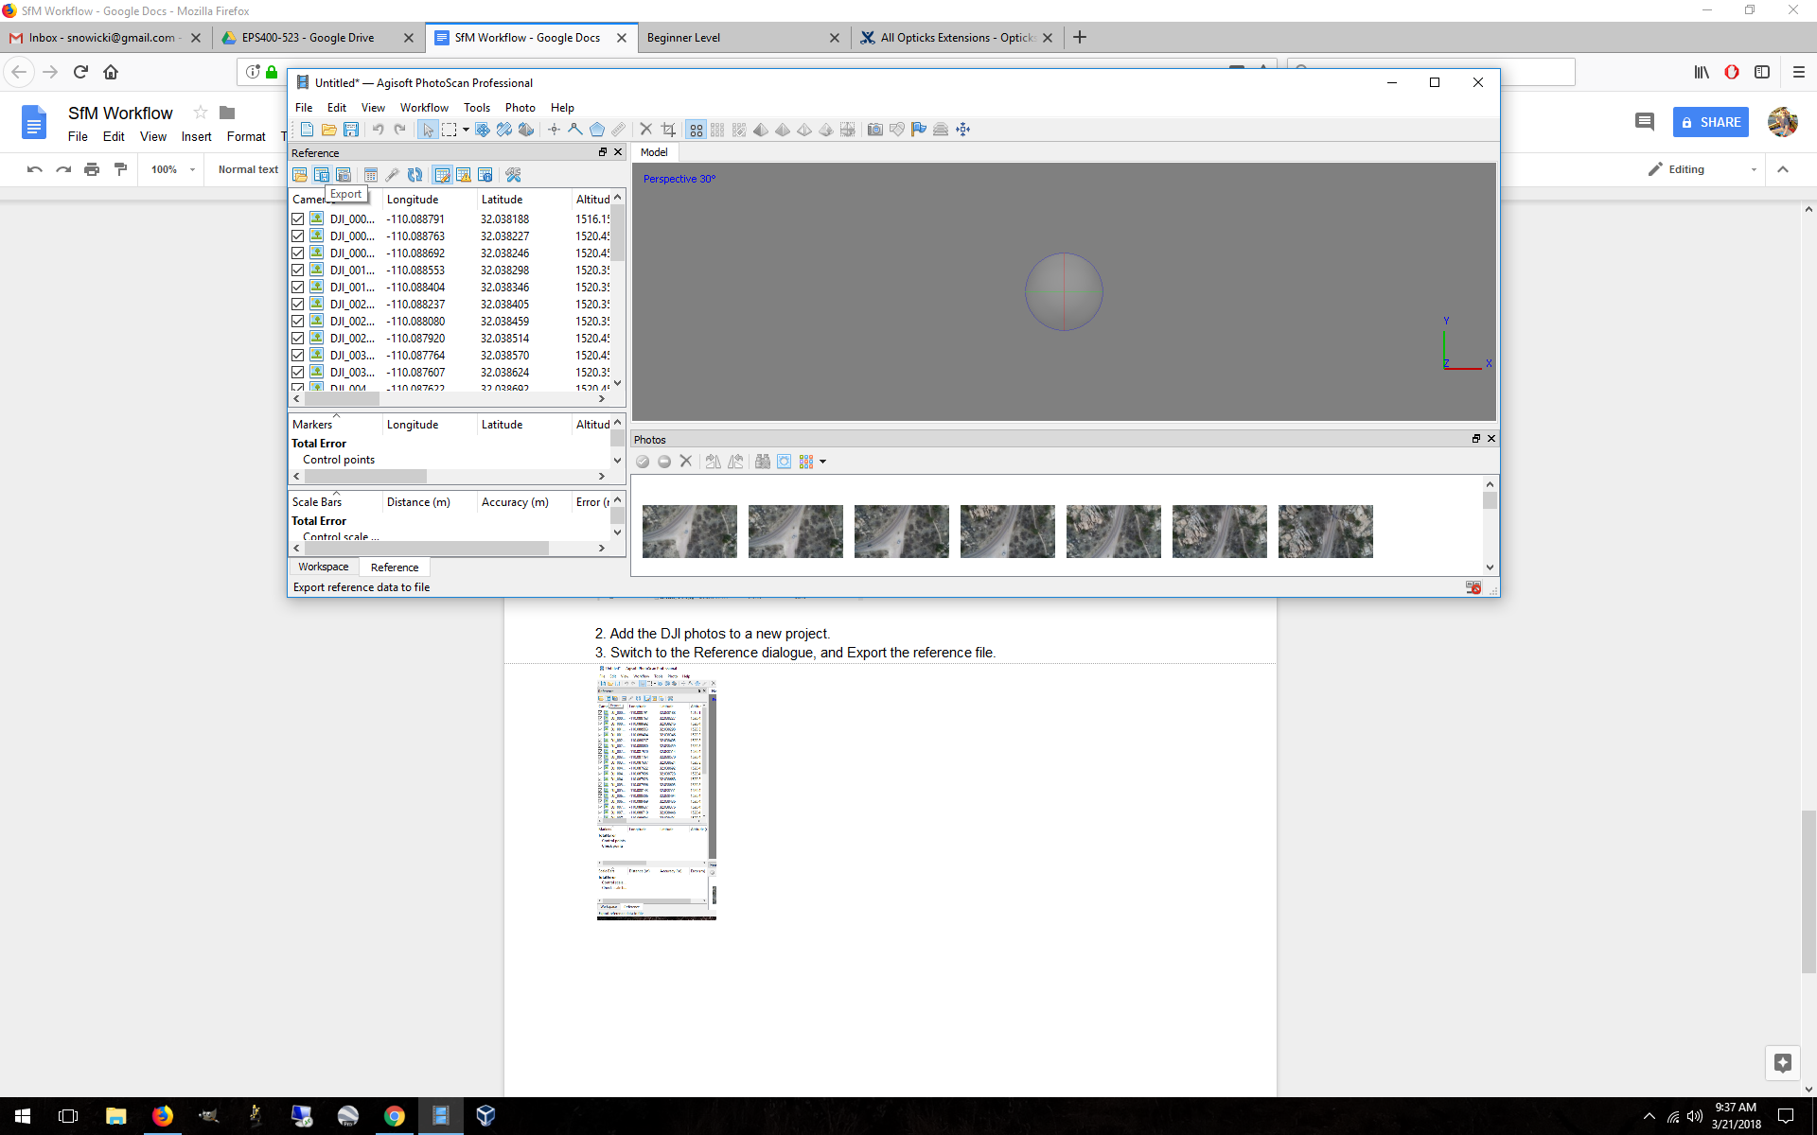

4. Load the unreferenced Flir images and export the reference file.

5. Open both files in a spreadsheet editor and copy the Lat, Lon and Alt fields from the DJI file to the empty fields of the FLIR file. Save the Flir file as csv.

6. Load the new Flir reference file in the Reference dialogue. All the images should now have positions.

7. Complete the steps in Part 1 above for the DJI images in order to derive a DEM.

8. Align Photos, and project the Flir orthoimages to the **DEM generated from the visible DJI images.**

9. Export the thermal orthomosaic and check its accuracy in QGIS or GoogleEarth.

**Part 4. Additional Processing Steps**

**Classifying point clouds in Agisoft Photoscan.**

If you are doing spatial analysis on the point cloud, DEM, or DTM, you will likely want to clean your point cloud, and generate a subset of all the points in order to look at either the ground or the above-ground structure.

<http://www.agisoft.com/pdf/PS_1.1%20-Tutorial%20(IL)%20-%20Classification%20and%20DTM.pdf>

Once you have a clean dense point cloud, the analysis will need to move out of Agisoft and into a more involved software package.

Cloud Compare is a great tool for point cloud manipulation, detecting change and other point cloud analyses.

<http://www.cloudcompare.org/>